CYBIT110 Chapter 7 Skills Assessment 1 - Configure Windows Storage

Background
Basic disk contains basic volumes, such as primary partitions, extended partitions, and logical drives. When you use basic disks, you're limited to creating four primary partitions per disk or three primary partitions and one extended partition with unlimited logical drives.
A disk that has been initialized for dynamic storage is called a dynamic disk. It gives more flexibility than a basic disk because it does not use a partition table to keep track of all partitions. The partition can be extended with dynamic disk configuration. It uses dynamic volumes to manage data. Operations to be performed:
- Create and delete the following:
  - Simple - a portion of a physical disk that functions as though it were a physically separate unit.
  - Spanned - combines areas of unallocated space from multiple disks into one logical volume, allowing you to more efficiently use all of the space and all the drive letters on a multiple-disk system. Needs minimum two disks of any size.
  - stripped (RAID 0) - created by combining areas of free space on two or more disks into one logical volume. Striped volumes use RAID-0, which stripes data across multiple disks. Needs minimum two disks.
  - mirrored (RAID 1) - a fault-tolerant volume that provides data redundancy by using two copies of the volume to duplicate the data that is stored on the volume. Needs minimum two disks.
  - parity (RAID 5) - a fault-tolerant volume with data and parity striped intermittently across three or more physical disks. If a portion of a physical disk fails, you can recreate the data that was on the failed portion from the remaining data and parity.
- Extend a simple or spanned volume.
- Repair mirrored or RAID 5 volumes.
- Reactivate a missing or offline disk.
On Windows, a virtual hard disk is a file that can use a ".vhdx" or ".vhd" extension and acts like a physical hard drive, but with the difference that this is a file stored on a real disk.
There are two VHD formats:
- VHD – supports virtual disks up to 2 GB
- VHDX – supports virtual disk up to 64 TB and is resilient to power failure events. Not supported on Windows 8 or Windows Server 2012.
There are two VHD types:
- Fixed—The VHD image file is pre-allocated on the backing store for the maximum size requested.
- Dynamic - The VHD image file uses only as much space on the backing store as needed to store the actual data the virtual disk currently contains. When creating this type of virtual disk, the VHD API does not test for free space on the physical disk based on the maximum size requested, therefore it is possible to successfully create a dynamic virtual disk with a maximum size larger than the available physical disk free space.
The Storage Spaces feature built into Windows allows you to combine multiple hard drives into a single virtual drive. It can mirror data across multiple drives for redundancy, or combine multiple physical drives into a single pool of storage. Storage Spaces is similar to RAID. To create a Storage Space, you need at least two physical drives on your PC. These can be internal drives or external drives connected via USB. Storage Spaces allow you to create a “storage pool” of two or more physical drives, grouping them together. Once you’ve created a storage pool made up of two or more physical drives, you can create three types of “spaces” using that pool:
- Simple space - designed to store only a single copy of your data across all the drives. If one of these drives fails, your data will be lost and corrupted. This is ideal for temporary data.
- Mirror space - designed to protect you from drive failure by storing multiple copies of your files. There are two types of mirror space
  - Two-way mirror stores two copies of your data across the drives
  - Three-way mirror stores three copies of your data across the drives
- Parity space - designed to keep a single copy of your data along with parity information. You’ll have more space and you’ll be protected if a single drive fails. The parity spaces are slower than other spaces and is not for data that you use frequently.

Objective
Understand the basics of Windows 11 storage capabilities.

Required VM
- Windows 11 VM

Part 1 Add Hard Disks to a VM
- While VM is powered off, select the Win11 virtual machine and click on Edit Virtual Machine Settings.
- On the Hardware tab, click Add.
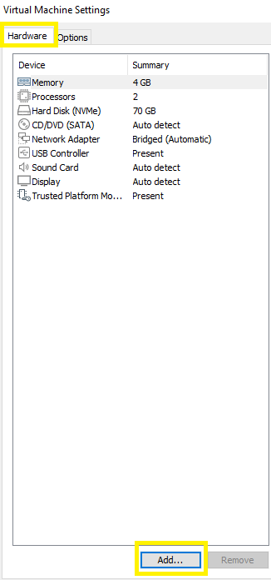
- In the New Hardware wizard, select Hard Disk and click Next.
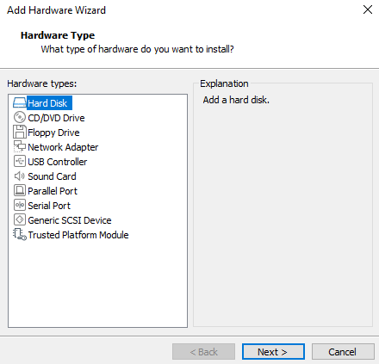
- In the Select the disk type page, there are a few types of disks that can be selected:
- IDE - Create an IDE device. You can add up to four IDE devices to a virtual machine.
- SCSI - Create a SCSI device. You can add up to 60 SCSI devices to a virtual machine. It is the recommended option.
- SATA – Create a SATA device. You can add up to 120 SATA devices.
- NVMe – Create a NVMe device. You can add up to 60 NVMe devices
  - NVME (Non-Volatile Memory) will be grayed out if you do not have an SSD NVMe installed
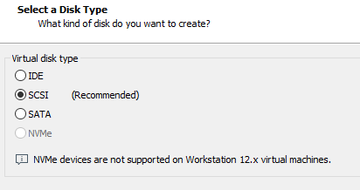
- Select the recommended disk type and click Next.
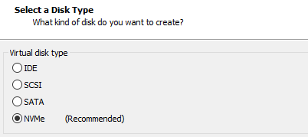
- In the Select a Disk page, click Create a new virtual disk and click Next.
Note: you have three options:
- Create a new virtual disk – a new virtual hard disk is created
- Use an existing virtual disk – one that was copied from another VM to use
- Use a physical disk – use an actual physical disk rather than a virtual one.
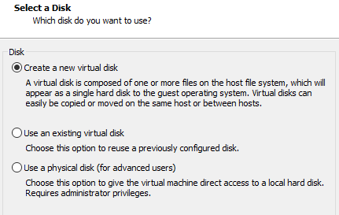
- In Specify Disk Capacity, in the Maximum disk size (GB), type 5 GB. Leave the default option to Split virtual disk into multiple files and click Next.
- You can set a size between 0.001GB and 2TB for a virtual disk.
- Allocate all disk space now – When using this option, it requires all of the physical disk space to be available now. If you do not select this setting, the virtual disk starts small and grows as you add data to it.
- Store virtual disk as a single file – This option stores the virtual disk as a single file.
- Split virtual disk into multiple files – This option stores the virtual disk in multiple files. A series of 2GB virtual disk files is created.
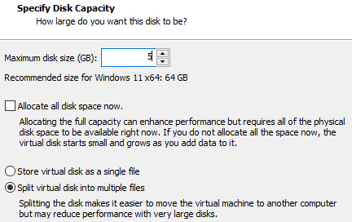
- In the Specify Disk File, accept the default filename and click Finish. Note: You can create any name to identify the virtual hard disk.
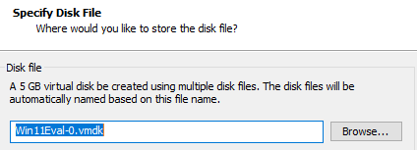
- The wizard creates the new virtual hard disk. The disk appears to the guest operating system as a new, blank hard disk.
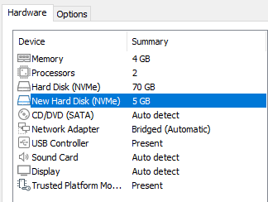
- Follow Steps 2-7 to create three additional virtual hard drives with 5 GB in each drive.
- Insert a screenshot of the new virtual hard disks in the VM Settings.
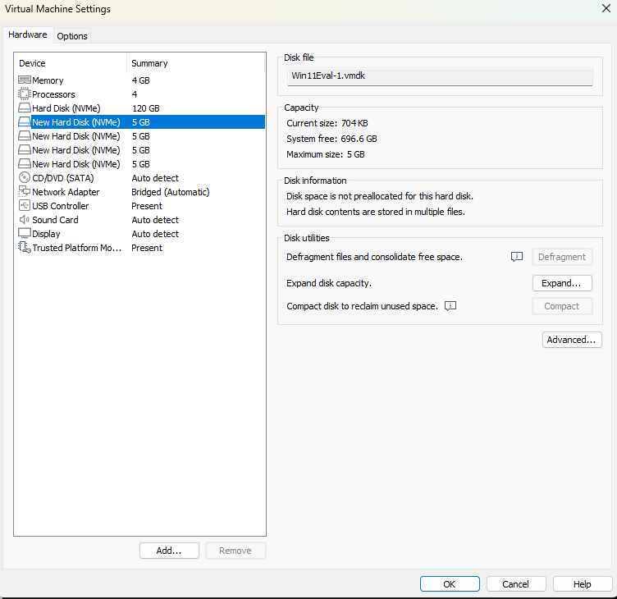
- Click OK to save your changes.
- Power on the Windows 11 VM and logon.

Part 2 Creating a Volume with DiskPart
- In the Search text bar, type cmd and to run as administrator, press Ctrl+Shift+Enter or click on Run as administrator.
- Type diskpart and press Enter to start the DiskPart utility in its interactive mode. Note that the prompt changes to DISKPART>.
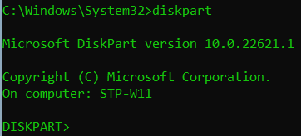
- Type help and press Enter to see a list of DiskPart commands.
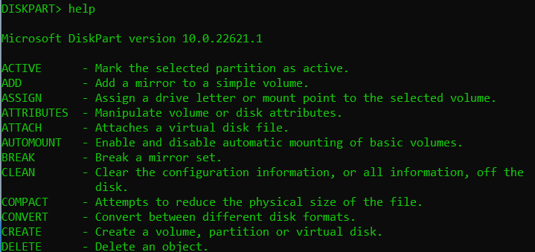
- Type help select and press Enter to see information about the select command.
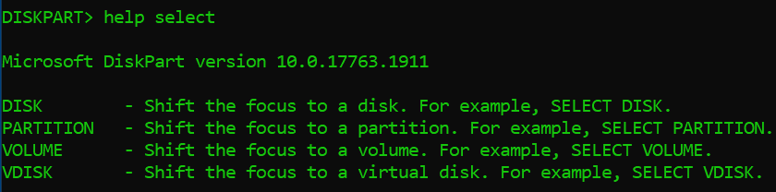
- Type help select disk and press Enter to see information and examples for the select disk command.
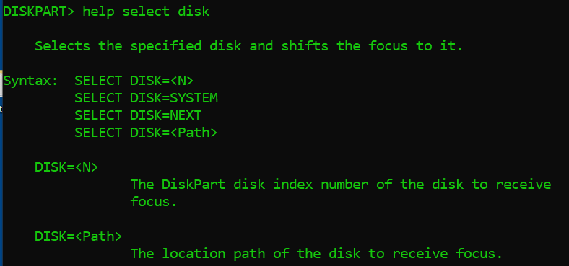
- To see what disks can be selected, type list disk and press Enter.
Note: Here is the breakdown of the output:
- Disk - the disks that have been added/installed
- Status - a disk status will be shown as either online or offline
- Size - the size of the disk will be shown in MB or GB
- Free – shows how much space is available to partition
- Dyn - it is listed as a dynamic disk if there is an asterisk (*) and a basic disk if no asterisk is present
- Gpt – it is listed as a GPT partition if there is an asterisk (*) and a MBR partition if no asterisk is present
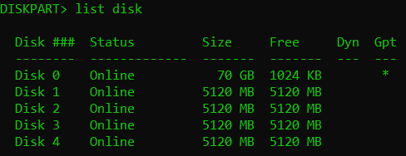
- The DiskPart utility has not been focused on a particular disk yet, so some commands will not be able to run. For example, type list partition, press Enter, and the help page outputs.
- To focus attention on the Disk 1, type select disk = 1 and press Enter. If you type list disk, there will be an asterisk next to Disk 1. That indicates that the disk is selected and can be focused on.
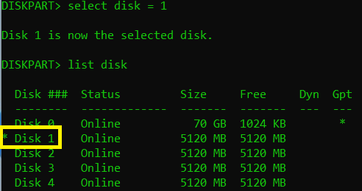
- Type list partition, press Enter, and note that there should be no partitions yet on the disk.
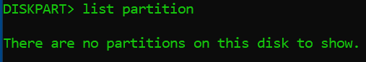
- To create a partition on the entire disk, type the command create partition primary and press Enter.
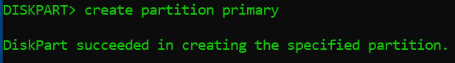
- Type the command active and press Enter. This will mark the disk’s partition as active.
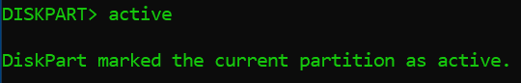
- Next, you will need to format the disk with the NTFS filesystem and a disk label, type the following command: format fs=ntfs quick label=”XX-drive” and press Enter. XX will be your initials.
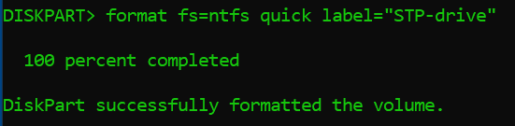
- To assign a drive letter, type the following command: assign letter=E: and press enter.
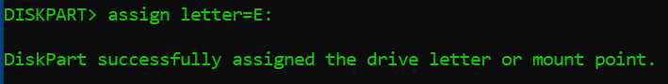
- Type the command list partition and press Enter. In Disk 1, there should be a partition listed now.
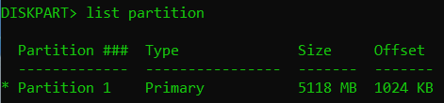
- To see what volumes are present in the DiskPart utility, type list volume and press Enter. Notice the new volume is listed as Volume 4 in the image below.
Note: Note that a DVD-ROM might be included in the volume listing, which does not rely on the selected disk.
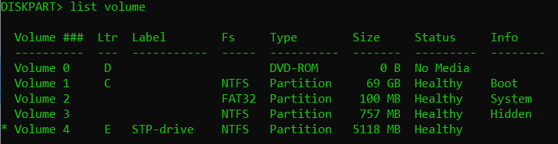
- Insert a screenshot of the result.
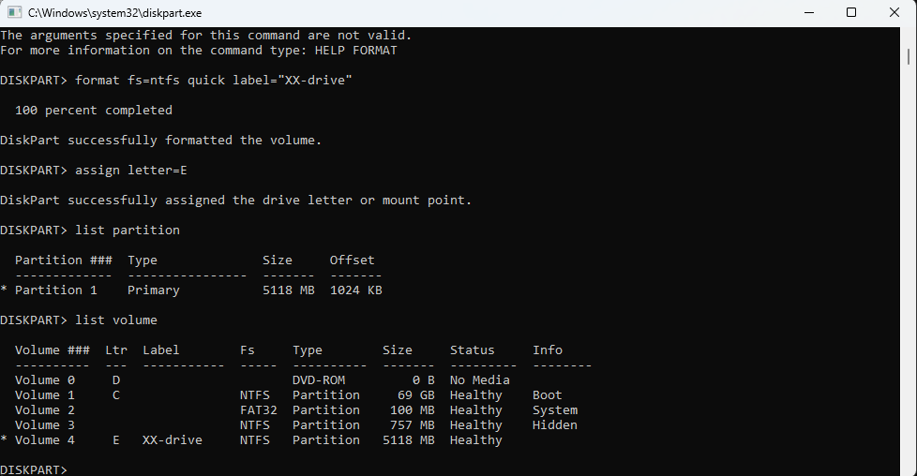
- To leave the DiskPart utility, type exit and press Enter.
- To close the command prompt window, type Exit and press Enter.

Part 3 Shrink a Basic Disk and Create a Simple Volume
You can decrease the space used by primary partitions and logical drives by shrinking them into adjacent, contiguous space on the same disk. For example, if you discover that you need an additional partition but do not have additional disks, you can shrink the existing partition from the end of the volume to create new unallocated space that can then be used for a new partition. There is no need to reformat the disk to shrink the partition. Must be administrators, or equivalent, is the minimum required to complete this procedure.
- Right-click the Start button and click Disk Management.
- You can only initialize a drive that's not yet formatted. When you initialize a disk, everything on the disk is erased. This action prepares the disk for use by Windows. After you initialize your disk, you can format it, and then store files on it.
- To initialize Disk2, Disk3, and Disk4, select MBR partition style. Then click OK.
Note: The two types of partition styles are the following:
  - Master Boot Record (MBR) – legacy partition that is used in BIOS systems with a disk storage space to 2 TB and supports up to 4 primary partitions, or 3 primary partitions and 1 extended partition combination
  - GUID Partition Table (GPT) – associated with UEFI systems that supports a disk storage up to 9.44 ZB and the ability to have up to 128 primary partitions
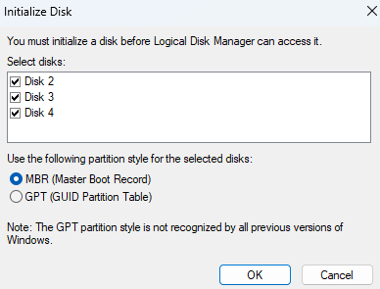
- Notice that the three disks were initialized and are online.
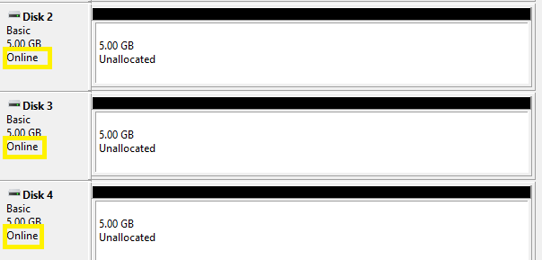
- To shrink a volume in Disk 1, right-click anywhere inside on XX-drive (E:) and click Shrink Volume.
Note: It will be a take a few moments while a query takes place for available shrink space.
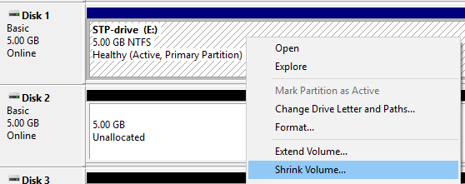
- In the Shrink E: window, notice the total size of the drive and how much it can shrink. Under Enter the amount of space to shrink in MB, type 2550 and click Shrink.
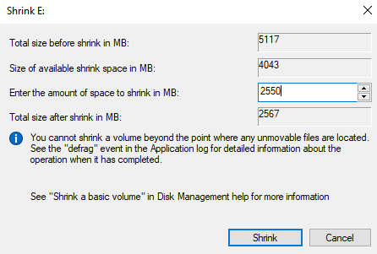
- Notice the new Unallocated partition in Disk 1.
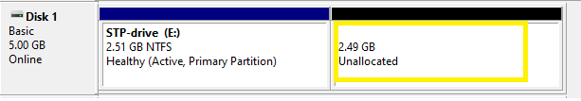
- Right-click on the Unallocated space and click New Simple Volume.
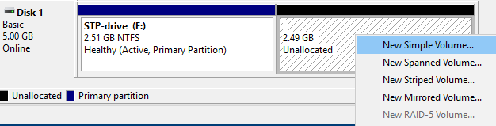
- In the Welcome page, click Next.
- In the Specify Volume Size page, leave the default volume size and click Next.
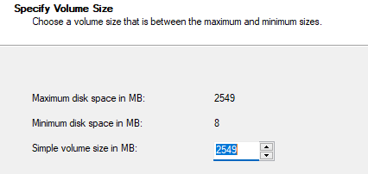
- In the Assign Drive Letter or Path, leave the assign drive letter as default and click Next.
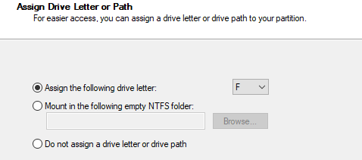
- In the Format Partition, change the File System to FAT32. In the Volume label text box, change the default name to XX-FAT32 (XX will be your initials) and leave the other options as default. Click Next.
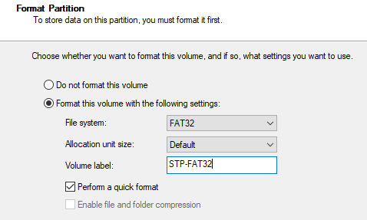
- In the Complete the New Simple Volume Wizard, click Finish.
- The new volume will appear in Disk 1.
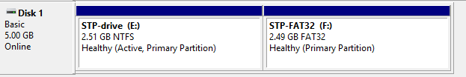
- Insert a screenshot showing the new volume.
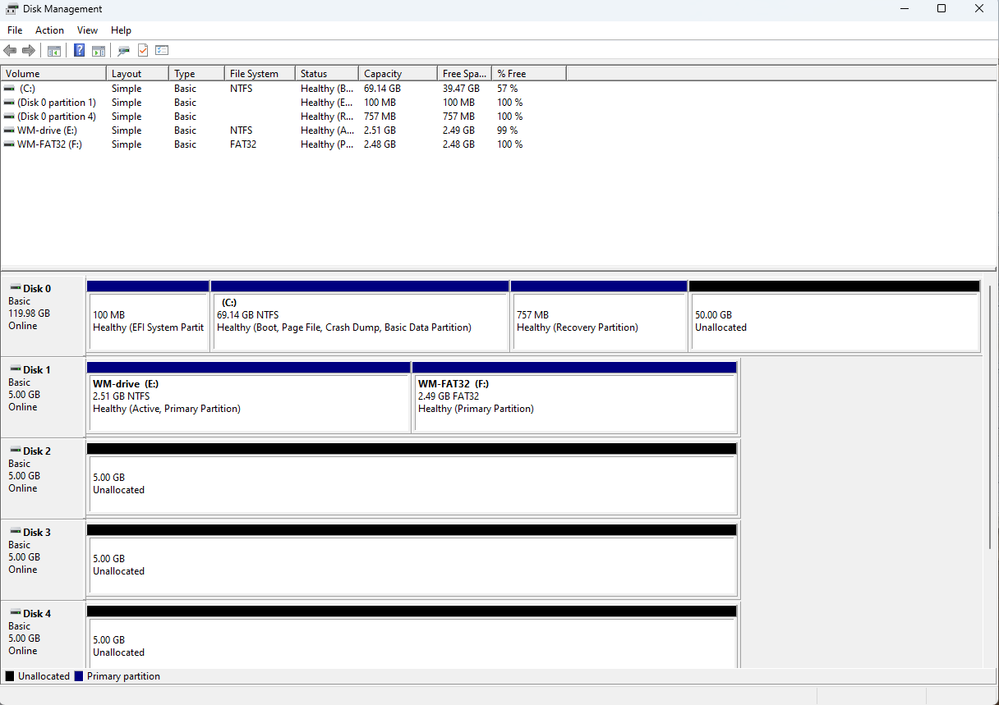

- Leave Disk Management open for next part.

Part 4 Working with Dynamic Partitions
- In the Disk Management snap-in, in the graphical display, right-click the Disk 2 box and choose Convert to Dynamic Disk.
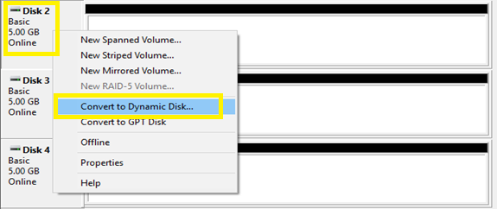
- In the Convert to Dynamic Disk page, select Disk 2 – 4 and then click OK.
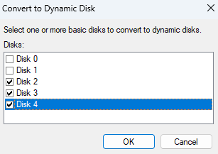
- Notice that the disks are now labeled as Dynamic.
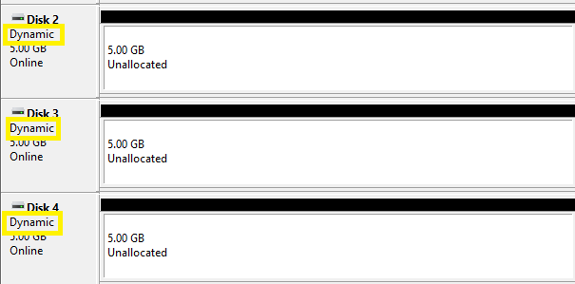
- To create a striped volume, right-click the unallocated space on Disk 2 and choose New Striped Volume.
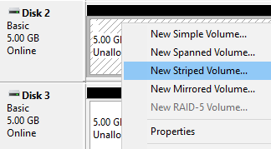
- In the Welcome page, click Next.
- The Select Disks page appears. In the Available box, select Disk 3 and then click Add. Disk 3 moves to the Selected box.
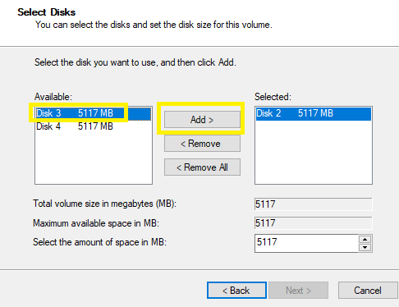
- Configure Disk 2 and Disk 3 contribution to their available disk space to the spanned volume. In the Selected area, select Disk 2 and in Select the amount of space in MB, type 1000. Notice that Disk 3 is automatically changed to 1000 as well. Click Next.
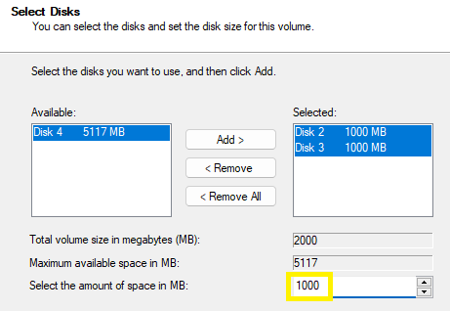
- In Assign Drive Letter or Path, select the drive letter S and then click Next.
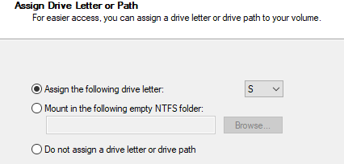
- In Format Volume, leave the Format this volume with the following settings option as default and in Volume Label, type Striped. Select the Perform a quick format check box and then click Next.
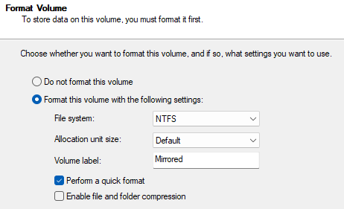
- In the Completing Volume Wizard page, click Finish.
- Notice that Disk 2 and Disk 3 is now a spanned volume with a drive letter S.
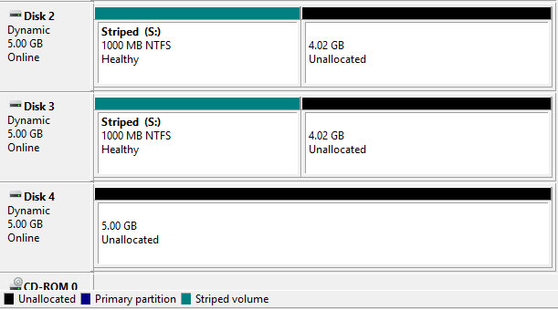
- To create a mirrored volume, right-click on Disk 2 unallocated space and select New Mirrored Volume.
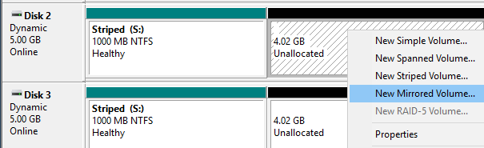
- Click Next in the Welcome Screen.
- Add Disk 3 to the Selected section. In Select the amount of space in MB, change the space amount to 3000. Click Next.
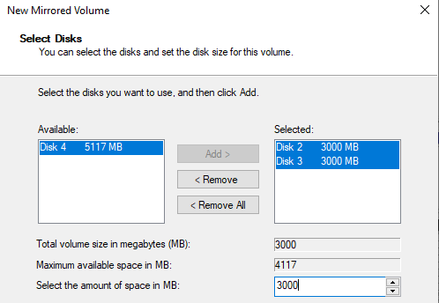
- For the Assign Drive Letter, select M and click Next.
- In the Format Volume page, leave file system as NTFS and change the Volume label to Mirrored. Select perform a quick format. Click Next.
- In the Completing Wizard page, click Finish.
- The Mirrored volume will be completed.
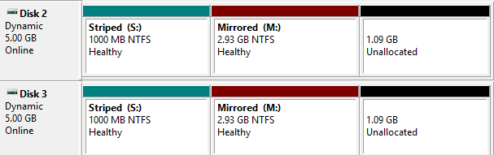
- To create a spanned volume with the rest of Disks 2 and 3 plus Disk 4, right-click on Disk 2 unallocated drive and select New Spanned Volume.
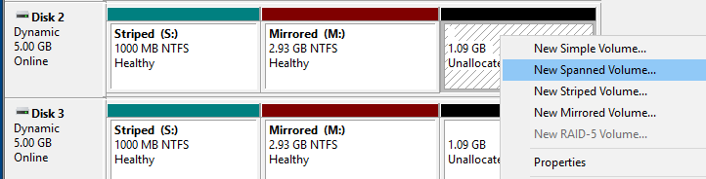
- In the Welcome page, click Next.
- Add Disks 3 and 4 to the Selected section. Notice that the Total volume size is 7351. In spanned volumes, the disks can be any size. Click Next.
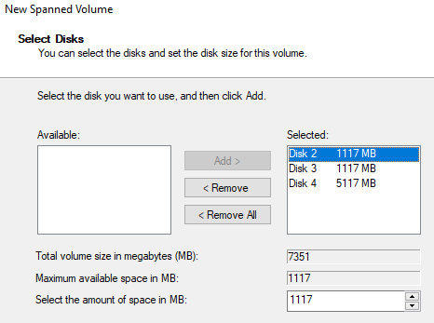
- For the Assign Drive Letter, select G and click Next.
- In the Format Volume page, leave file system as NTFS and change the Volume label to Spanned. Select perform a quick format. Click Next.
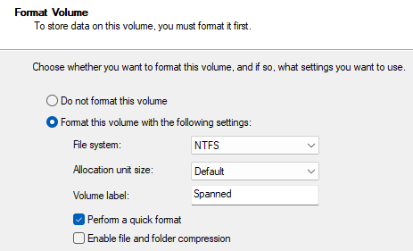
- Click Finish.
- Notice that all of the volumes have a different color to represent the different type of volume.
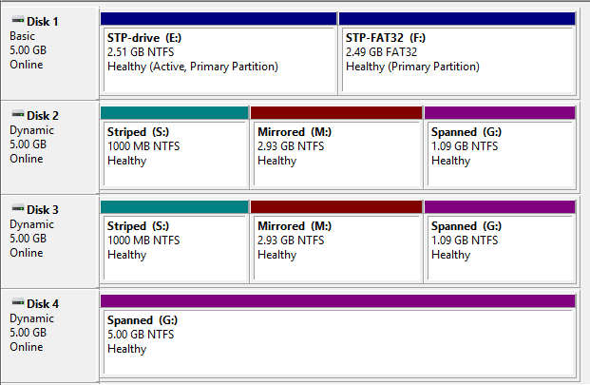
- Insert a screenshot in Disk Management window that shows Disks 1 – 4.
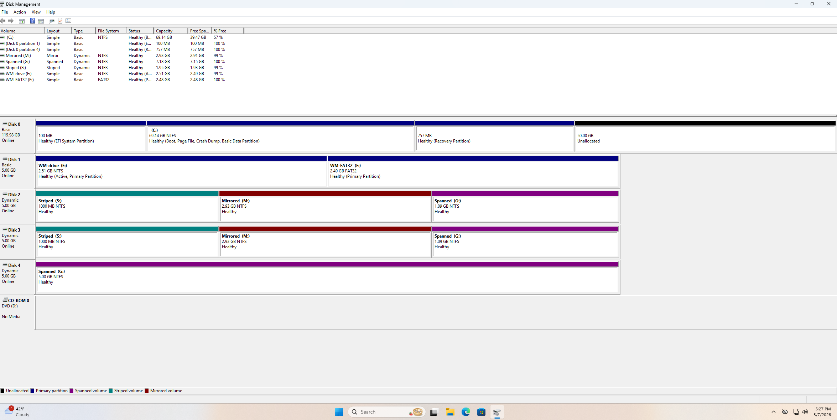
- Leave Disk Management window open.

Part 5 Creating VHD Disk
A virtual hard drive (VHD) refers to a digital emulation of a physical disk drive. Unlike a physical hard drive that is tangible and occupies physical space, a virtual drive exists purely as a file on your system but behaves like a physical disk.
- Click on File Explorer > This PC > Local Disk (C:). Create a new folder called VHD Storage.
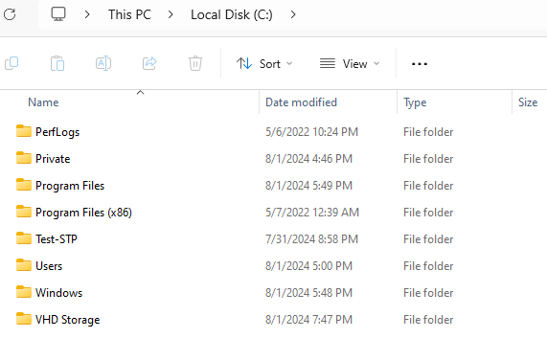
- If necessary, right-click the Start button and select Disk Management.
- In the Disk Management window, in the top menu, click Action and select Create VHD. This launches the Create and Attach Virtual Hard Disk window.
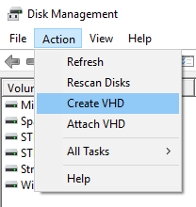
- Next to Location, click the Browse button.
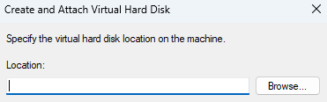
- Open C:\ drive and click on C:\VHD Storage folder. In the File name field, type the text XX-VHD (XX will be your initials) and click the Save button to close the Browse Virtual Disk Files window.
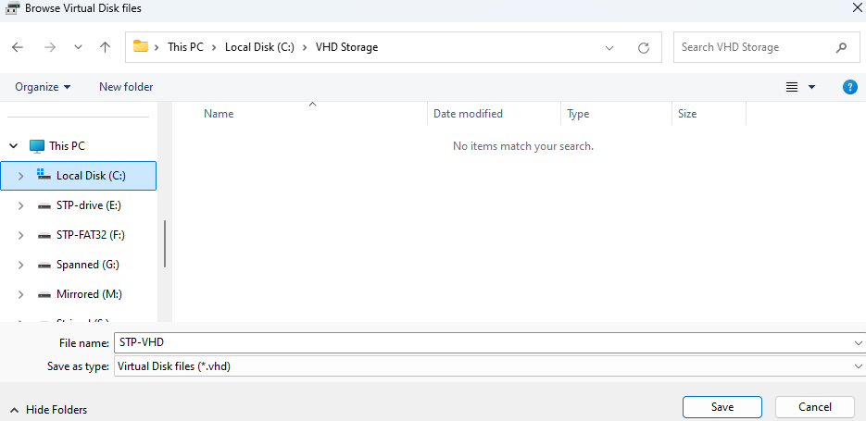
- In the Create and Attach Virtual Hard Disk window, enter the value 5 in the Virtual hard disk size field. Click to change the unit size from MB to GB.
- Confirm that VHD is the virtual hard disk format selected.
- Select Dynamically expanding under Virtual hard disk type to allow the VHD file to grow as required and not allocate all the disk space when it is first created.
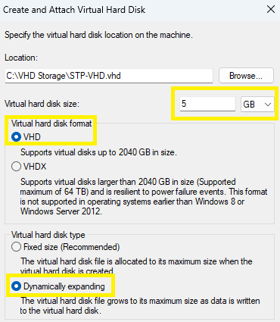
- Click OK to create the VHD.
- Scroll down to see a new disk (Disk 5) appears in the graphical disk view with an Unknown disk type and a status of Not Initialized. A VHD is identified with the light blue graphical drive icon.
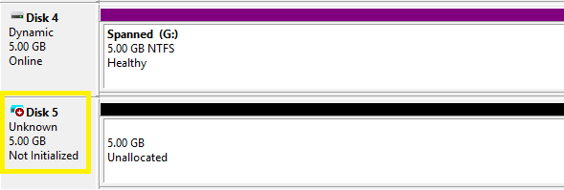
- Right-click the 5 GB of unallocated space from the VHD disk and note the available volume creation options are all grayed out and unavailable. The disk needs to be initialized. Initializing a disk prepares the disk to be partitioned and formatted.
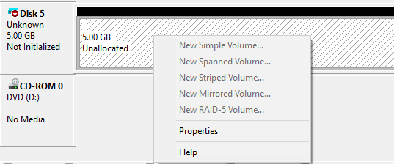
- Right-click the VHD’s disk name next to the blue drive icon and select Initialize Disk from the shortcut menu.
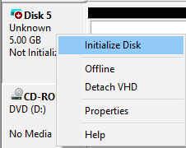
- In the Initialize Disk window, select MBR and click OK.
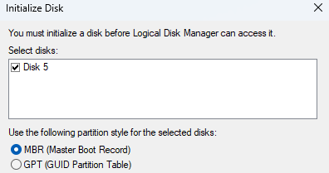
- Right-click the unallocated space from the VHD disk and select New Simple Volume.
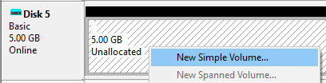
- In the Welcome page, click Next.
- In the Specify Volume Size, leave with default volume size and click Next.
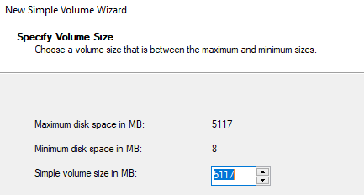
- Change the drive letter to V and then click Next.
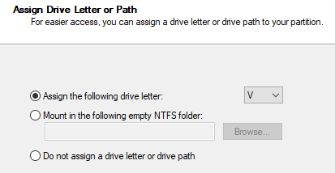
- Change the default volume label of New Volume to XX-VHDVOL (XX will be your initials). Click Next.
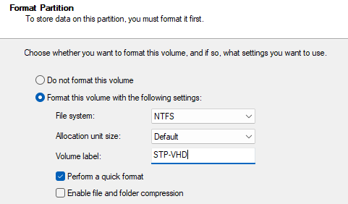
- Click Finish to complete the New Volume Wizard. During the creation and formatting of the drive, Windows might mistakenly prompt you to format the new volume even though the wizard is performing that task for you. Just click Cancel on the prompt asking “Do you want to format it?”
- The new volume will be created using a virtual space from Disk 0.
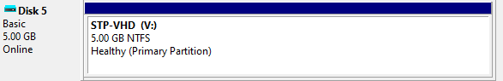
- Insert a screenshot below showing the new VHD.
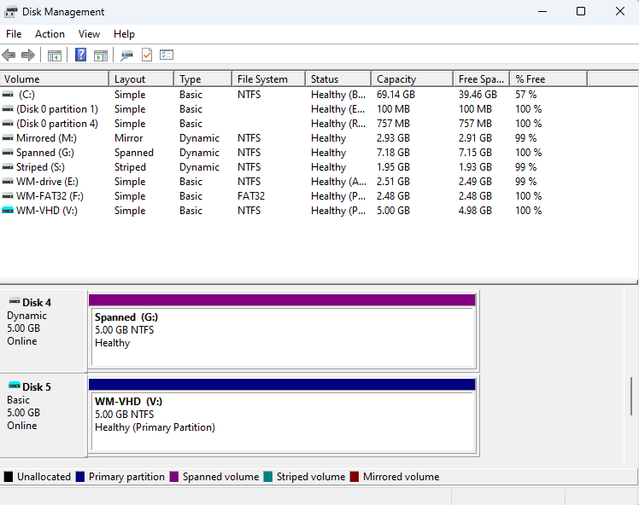
- Note the size of the newly created partition in Disk Management. It is reported as the full size of 5 GB you specified in the New Volume Creation Wizard. Switch to the File Explorer window and browse to C:\VHD Storage. Note the size of the VHD file in that folder and the fact that it is much smaller that the reported volume size.
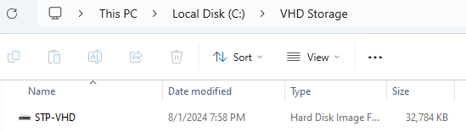
- Why is the size smaller in vhd file than in Disk Management Disk 5? Look in Background under VHD types.
Because its just an image of the VHD and not the entire thing
- In the File Explorer window, right-click the V:\ drive letter and select Properties from the shortcut menu. Note the Used Space and Free Space values shown on the General tab.
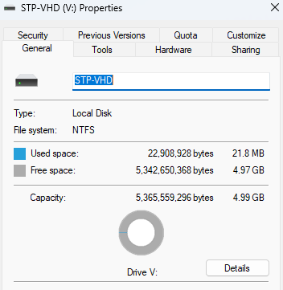
- Close any open window and restart the VM.
- Open File Explorer. Notice that XX-VHD (V:) is not present.
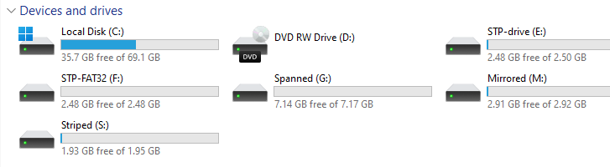
- Insert a screenshot showing all the drives in Devices and drives.
- To use the VHD drive, the VHD needs to be attached or mounted.
- Open Disk Management. Click Action -> Attach VHD.
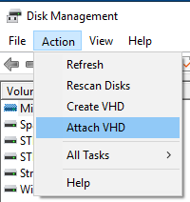
- Click Browse and go to the C:\VHD Storage folder.
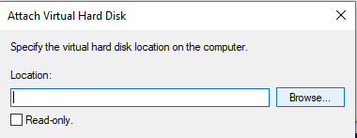
- Double-click XX-VHD.vhd file and then click OK.
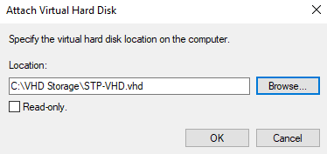
Note: You can even attach/mount the VHD and right-clicking on XX-VHD.vhd file and click Mount.
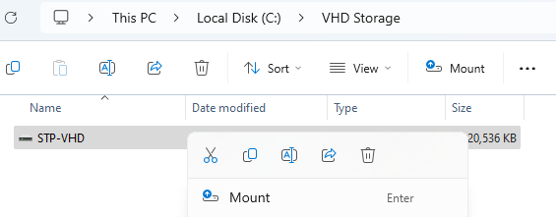
- The V:\ drive should appear again.
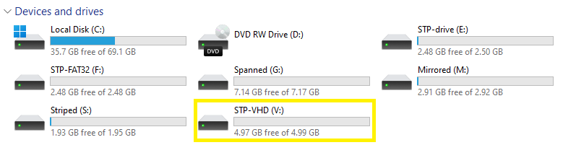
- Insert a screenshot showing V:\ drive in Devices and Drives.
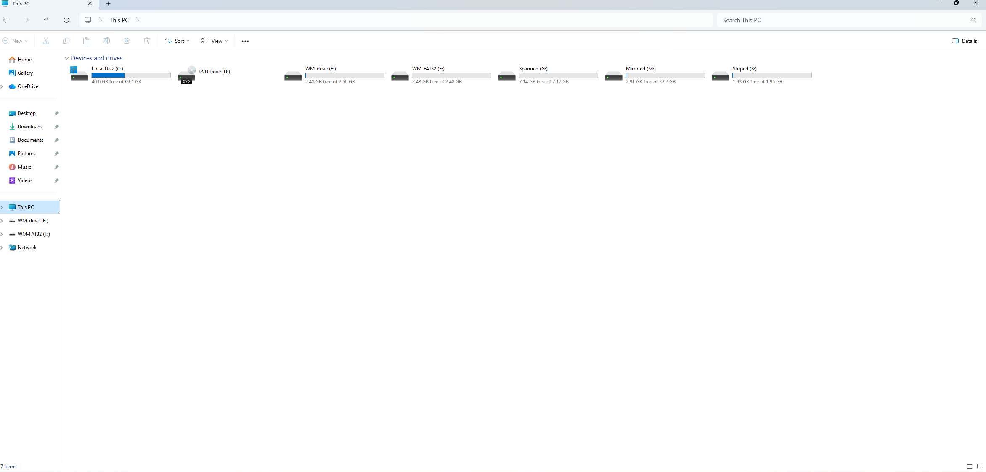
- To permanently delete the VHD, return to Disk Management.
- Right-click on the V:\ drive and click Delete Volume. Then click Yes to continue the deletion.
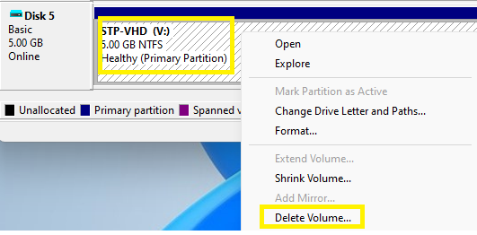
- Next the VHD needs to be detached. Right-click on the disk and click Detach VHD. 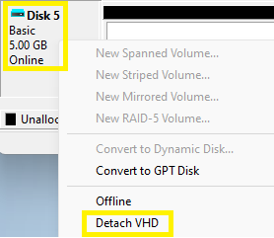
- Click OK to detach the VHD. The VHD file is removed from the system drive.
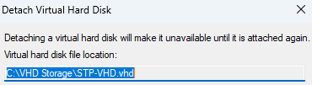
- Open File Explorer and navigate to C:\VHD Storage.
- Delete the XX-VHD file.
- Close any open window.

Part 6 Using Storage Space
Storage Spaces helps protect your data from drive failures and extend storage over time as you add drives to your PC. You can use Storage Spaces to group two or more drives together in a storage pool and then use capacity from that pool to create virtual drives called storage spaces. These storage spaces typically store two copies of your data so if one of your drives fails, you still have an intact copy of your data. If you run low on capacity, just add more drives to the storage pool. The disks to be used for a storage space need to be completely unallocated.
- Right-click the Start button and select Disk Management.
- In the Disk Management window, on Disk 2 or Disk 3, right-click on Spanned (G:) and click Delete Volume. In the Do you want to continue window, click Yes.
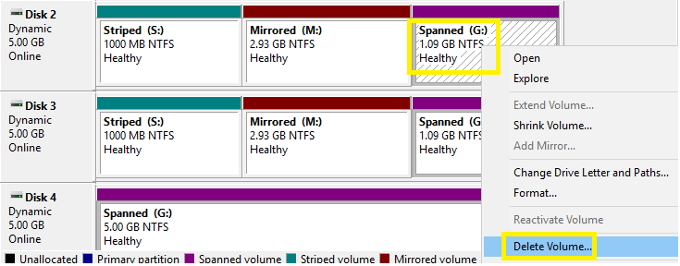
- You will see unallocated space in Disk 2, 3, and entirely in Disk 4. Repeat the step to delete for the Mirrored and Striped volumes. Disks 2 – 4 should be entirely unallocated.
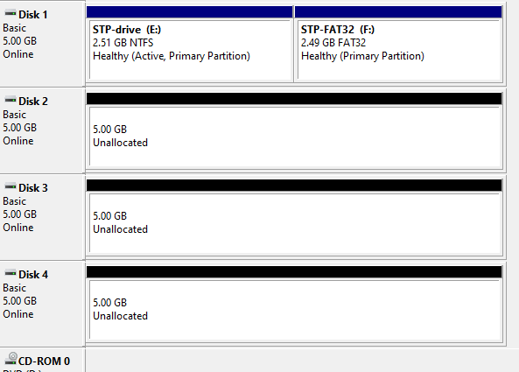
- Restart the VM and logon back in. If the VM is not restarted, the Storage Space may not see the unallocated disks.
- In Search bar, type Storage Spaces. Click on Manage Storage Spaces app.
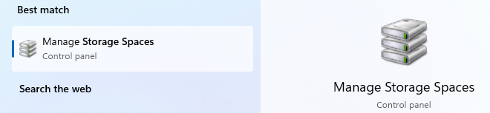
- Click the link Create a new pool and storage space. When you are prompted by User Account Control for permission to run the application, click Yes.
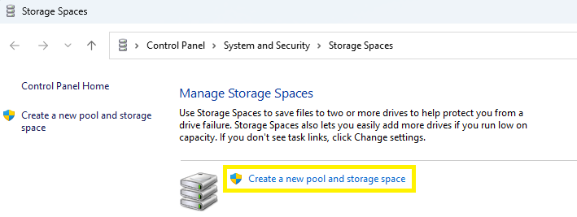
- Note that the Storage Spaces agent has discovered the three disks as an available disk and has already selected them by default. Select only Disk 2 and Disk 3. Click the Create pool button.
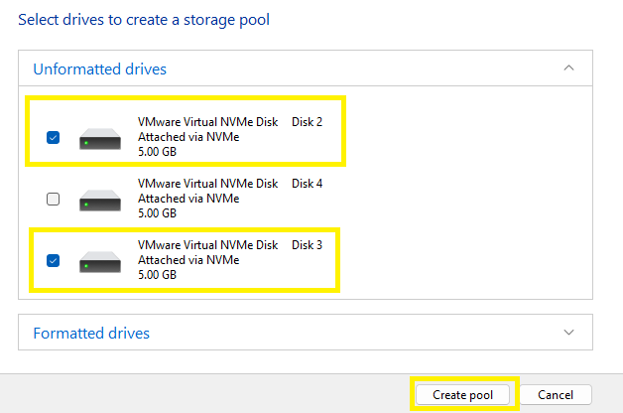
- In the Enter a name, resiliency type, and size for the storage space window, complete the following:
  - In the Name text box, type XX-StorageSpace (XX will be your initials)
  - Change the Drive letter to “P”
  - In Resiliency type, click the drop-down and select Simple (no resiliency).
  - In the Size (maximum) field, enter the value 10.
- Click Create storage space button.
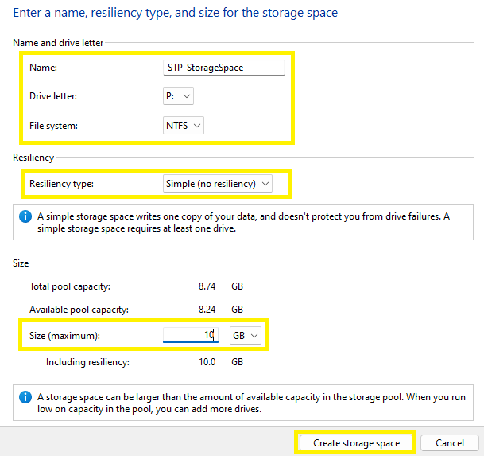
- In the Manage Storage Spaces window, the new storage pool was created with the storage space XX-StorageSpace (P:).
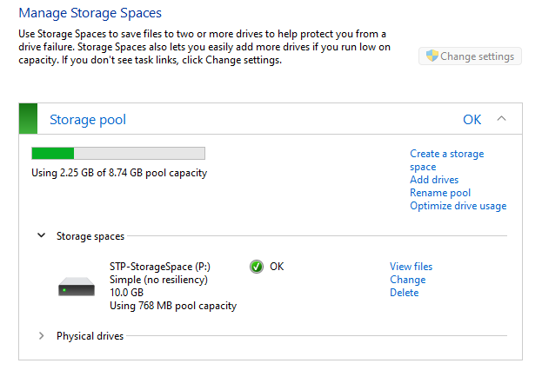
- Open Disk Management and notice that Disks 2 and 3 are no longer displayed as disks visible to Disk Management. The new Storage space volume is now present.
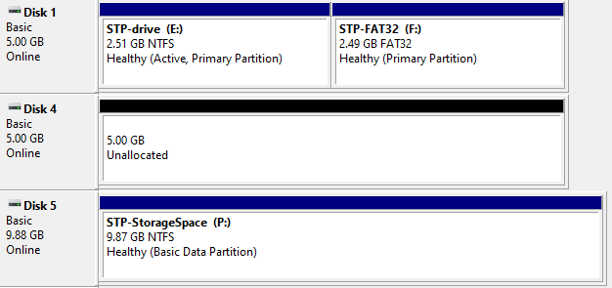
- Insert a screenshot showing the new volume in Disk Management.
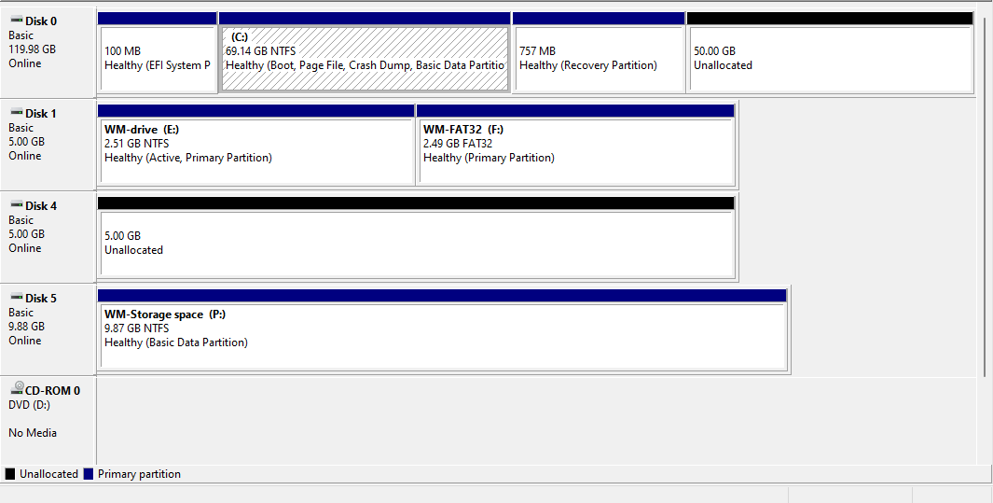
- Close Disk Management and Storage Space.
- Open Storage Spaces.
- Note that the links to manage the existing storage pool and its storage spaces are grayed out. Click the Change settings button to elevate the Storage Spaces settings window to Administrator equivalent levels.
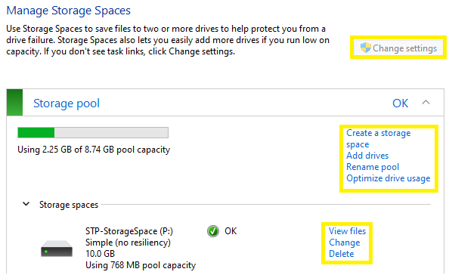
- If space on the disks were to get nearly full, another disk can be added to the storage pool. To add another drive, click Add drives link.
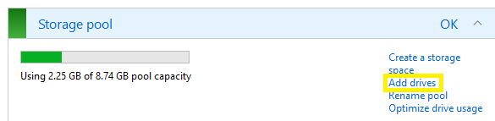
- Disk 4 is available to be added in the Add drives wizard. Confirm that the Optimize drive usage to spread existing data across all drives option is checked. Click the Add drives button.
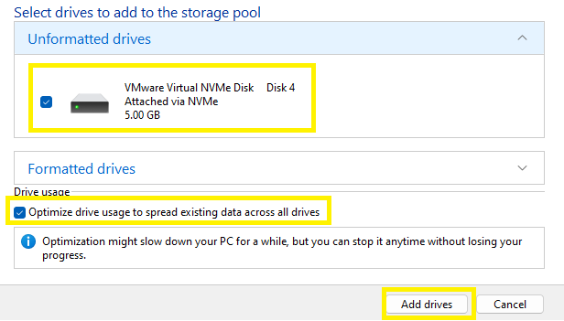
- Click on Physical drives underneath Storage spaces. There should be three drives present.
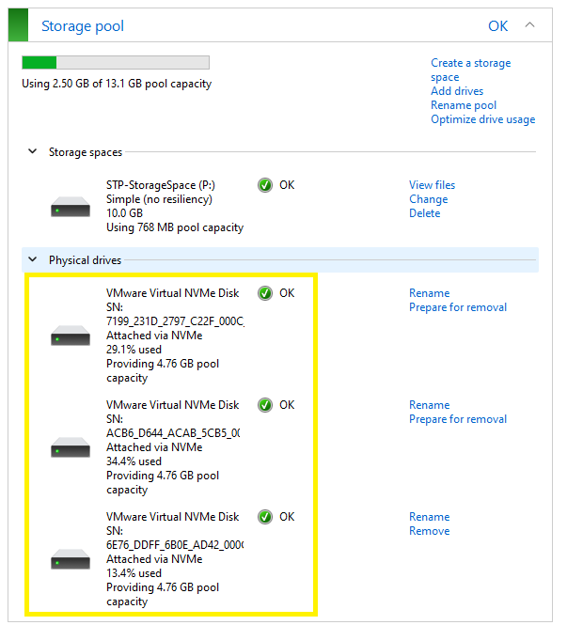
- Insert a screenshot showing the name of the Storage Pool, and the three drives in Physical drive section.
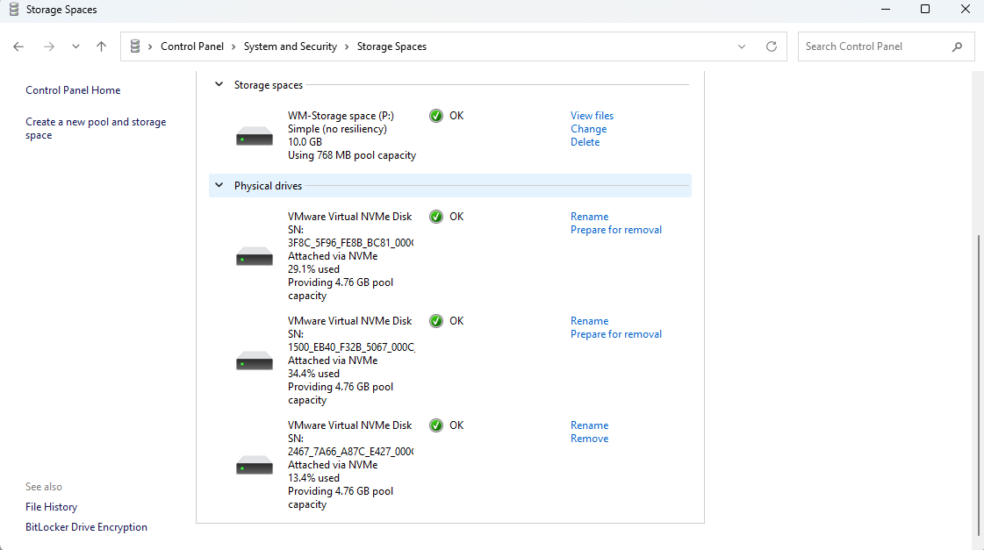
- To delete a storage pool, under Storage spaces, click the Delete link.
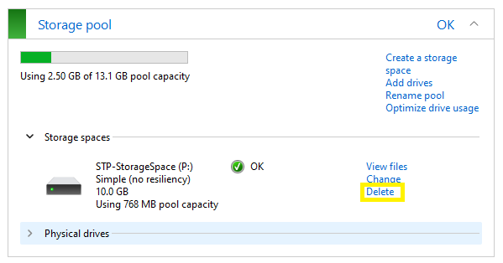
- Note the warning that appears regarding the recovery of the files the volume contains. Click the Delete storage space button.
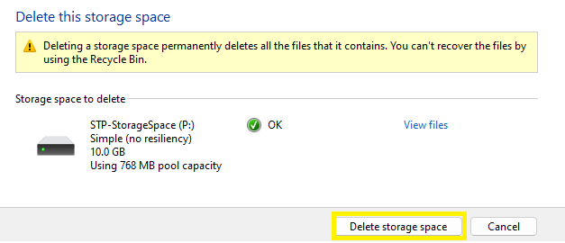
- Now to delete the storage pool, click Delete pool link.
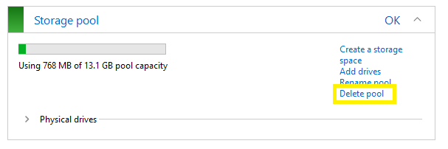
- In the Delete this storage pool screen, click Delete pool.
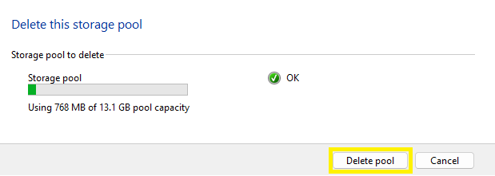
- Close Storage Spaces and open Disk Management.
- Disks 2-4 should now be present.
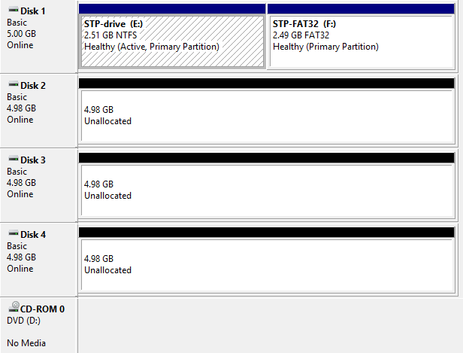
- Close Disk Management and shutdown Windows 11 VM.

Resources
https://www.howtogeek.com/109380/how-to-use-windows-8s-storage-spaces-to-mirror-combine-drives/

